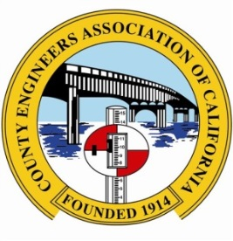
2015 NOMINATION FORM

CEAC ENGINEER OF THE YEAR AWARD
& CANDIDATE FOR NACE RURAL OR URBAN
ENGINEER OF THE YEAR AWARD

APPLICATION DEADLINE: 10/15/2015

Nominee: Title:

County: Department:

Office Address: Telephone:

City: State: Zip Code:

County Population:

Nominated for: NACE RURAL NACE URBAN “ENGINEER OF THE YEAR AWARD”

RURAL ENGINEER WILL REPRESENT A COUNTY WITH A POPULATION LESS THAN 100,000

URBAN ENGINEER WILL REPRESENT A COUNTY WITH A POPULATION GREATER THAN 100,000

The CEAC Memorial Fund and Scholarship Committee will use the following information as selection criteria. Along with this nomination form, you must also submit the Narrative Form on the following criteria, to support your nomination.

All nominees will be considered for both the CEAC and NACE Awards.
- Major achievements in County engineering;
- Professional positions held, beginning with current employment;
- CEAC activities, including number of years in CEAC, committee service, and offices held;
- NACE activities, including number of years in NACE, committee service, and offices held;
- CEAC Regional Association activities;
- Education, including colleges attended and degrees received;
- Professional licenses;
- Professional organizations;
- Previous professional awards;
- Published articles in trade or professional journals and formal papers presented to trade or professional groups;
- Community service or club awards.

Nominated by: Title:

County: Department:

Email: Telephone:

Office Address:

Submit all information to: Steve Kowalewski, Chair
CEAC Memorial Fund and Scholarship Committee
Contra Costa, Public Works Department
255 Glacier Drive
Martinez, CA 94553

OR via email to: skowa@pw.cccounty.us
Questions?
Email Steve Kowalewski at skowa@pw.cccounty.us or Phone: (925) 313-2225 Fax: (925) 313-2333

